MTAT Equality, Diversity and Inclusion Policy

Scope

This policy applies to the responsibilities held by organisation Microsystems Therapies and Training (MTAT) to promote and uphold equal opportunity to patients, learners, staff and visitors.

1.Introduction

MTAT is committed to making its services accessible and inclusive, regardless of an individual’s protected characteristic (Equality Act 2010)and recognises the positive benefits of maintaining an Equality, Diversity and Inclusion Policy for all its students, patients and visitors and the organisation as a whole and that it is essential to provide equal opportunities to all persons without discrimination.

This policy sets out how MTAT will seek to meet our commitments to comply with obligations under anti-discrimination legislation to ensure that all of our patients, learners and third parties connected with MTAT are able develop their full potential and talents. MTAT strives to be a leader in equality of opportunity and an example of best practice.

This policy exists to:

* Ensure that MTAT carries out its activities within a framework that respects and promotes equal opportunities and alongside legislative requirements.
* Ensure that MTAT is pro-active in promoting equality of opportunity.
* Make explicit the rights and responsibilities of all patients, learners, staff and visitors.
* Commit MTAT to monitoring the implementation of this policy and the evaluation of its effectiveness.

2. Statutory Requirements

This policy is in accordance with the relevant legislation concerning discrimination, including but not limited to:

* Equality Act 2010
* Human Rights Act 1998
* Sex Discrimination Act 1975

and the promotion of Equality, Inclusion and Diversity under Equality and Human Rights Commission (EHRC).

3. Voluntary Regulatory Requirements

This policy is in accordance with professional conduct and practice guidelines encompassing *CNHC Code of Conduct, Ethics and Performance*, June 2014, in particular with reference to ‘A3: A legal duty to promote equality’ (Appendix 1) and *FHT Code of Conduct and Professional Practice* section ‘3.4’ (Appendix II) and associated sections. MTAT also recognises equality, diversity and inclusion guidelines laid down by *Core Curriculum for Microsystems Acupuncture, British Acupuncture Council Safety and Ethics and Performance* and any applicable *National Occupational Standards.*

4. Protected Characteristics:

There are nine protected characteristics which are covered by equality and diversity guidelines and legislation and these are:

* Age
* Sexual Orientation
* Sex
* Gender Reassignment
* Disability, including learning disabilities, mental health concerns and temporary disabilities
* Race, ethnic origins or racial identity
* Religion and belief
* Marriage and Civil Partnership
* Pregnancy and Maternity

In addition to these Protected Characteristics MTAT also considers the following to be characteristics which should be protected by the organisation:

* Mode of study/work including part time and distant learners/workers
* Those with caring responsibilities and/or dependants
* Those affiliated to a trade association
* Socio-economic status or history
* The status and form of someone’s personal relationship(s)

The law of the land will always take precedence over the characteristics detailed in section 4.

5. Equal Opportunities Statement of Intent:

MTAT is committed to encouraging and ensuring fairness and equality of opportunity for all during their association with the organisation.

MTAT celebrates, promotes and values the diversity brought to it by individuals, and believes that it will benefit from engaging learners, patients and connected third parties from a variety of backgrounds by meeting the needs of a diverse membership. The organisation will treat all applicants, students, patients and connected third parties with respect and dignity, and seek to provide an environment to work, learn and live in free from discrimination, harassment or victimisation.

The organisation opposes practices which, directly or otherwise, discriminate against, harass or victimise those who fall into the protected characteristics.

The organisation will ensure that individuals are treated solely on the basis of their merits and abilities.

The organisation will act to ensure learners and patients will receive equal and unbiased representation, access to services, and be free from harassment, irrespective of whether or not they fall within the protective characteristics. The protected characteristics list is not an exhaustive one and although a section of the organisation may not be mentioned above, that does not mean that they are not covered by this policy.

MTAT will strive to:

* Deliver equality of opportunity for all applicants, learners, patients and connected 3rd parties that may come into contact with us.
* Make this policy known to all applicants, staff, learners and partner organisations.
* Eliminate any conditions, procedures and individual behaviour that can lead to discrimination, harassment and victimisation even where there was no intent to discriminate, whilst recognising that individuals may experience disadvantage on more than one level.
* Offer services and representation fairly to all students and patients and ensure that anyone in contact with the organisation is treated with respect.
* Work proactively to involve students and patients in its activities who are typically under-represented or under-supported or systematically oppressed.
* Provide a working and learning environment in compliance with all relevant legislation. This policy will be amended as appropriate to meet the demands of future legislation. This organisation’s policy is guided by all current and relevant legislation.
* Achieve a culture in which diversity is embedded in all MTAT’s activities.
* Ensure mechanisms are in place for responding to complaints of discrimination, harassment and victimisation
* Monitor practices regularly to ensure that the organisation meets its commitment to equality of opportunity.

6. Areas of Responsibility

The organisation recognises that all of its students have a duty to support and uphold the principles contained in its Equality, Diversity and Inclusion and supporting policies. The commitment of all members of the organisation’s community is required to make the policy a success.

The Equality, Diversity and Inclusion Policy is the responsibility of every member of the organisation. However, the proprietor holding management, supervisory and senior position and student representatives in the organisation have additional and particular responsibilities to ensure the effectiveness of its application and that all staff and students are aware of its implementation.

The development, implementation and operation of the Equality, Diversity and Inclusion Policy is the responsibility of the proprietor of MTAT organisation and they have overall responsibility for ensuring that the organisation operates within a framework of equality of opportunity.

7. Equal Opportunity in Study Provision

MTAT understands that the needs of different groups vary and will therefore strive to provide according to need, which in some cases will result in different provisions.

MTAT recognises the right for students to form associations of interest and to debate freely, providing this does not trespass on the freedoms of others to do the same.

MTAT is committed to making our service provision accessible to all students. All reasonable adjustments will be made to enable this. Where offices are inaccessible, staff and elected officers will endeavour to find alternative space for meetings and events in order not to exclude any interested party.

8. Students, Applicants and 3rd Party Complaints

MTAT takes equal opportunities extremely seriously. If any student has any cause to believe that any aspect of this policy has not been adhered to, they can raise their concern in writing to the organisation in writing to the Principal. All complaints will be investigated thoroughly and will be investigated and any serious breaches of this policy could result in dismissal from course attendance.

9. Monitoring and reviewing

MTAT will establish effective monitoring, reviewing and record-keeping systems to ensure effective implementation and development of this Policy. MTAT will undertake monitoring in a variety of ways including the compilation of learners EDI needs via MTAT Equal Opportunities Monitoring Form (Appendix III) in order to protect the characteristics (and other characteristics) of learners, patients and staff. MTAT will also monitor the experience of learners. EDI reports will be available to appropriate regulatory and statutory bodies upon request.

10. Disclaimer

By producing this Policy, MTAT is not implying or accepting that the organisation has not sought to apply fair standards of practice in the past but we do recognise the need to constantly examine policy and practice to reflect changing standards and expectations.

The formulation of this policy has not been prompted by any allegations of unfairness or inequality being practised by the organisation or its staff or students. This policy is functioning entirely in accordance with the law at all times. We recognise that there are many types of discrimination and this policy, (as well as related documents) does not attempt to address them all. The aim of the organisation is to ensure that a framework of equal opportunities exists so that any form of discrimination can be addressed as the need arises.

11. Not continuing patient/student care

MTAT understands that it has a legal obligation to promote equality in line with human rights and anti-discriminatory law. Whilst MTAT make every effort to ensure that discriminatory practise and/or prejudice does not affect patient care and wellbeing and student right to equality, MTAT reserves the right to refuse continuing patient/learner care with clear justification that such a decision is not based on discrimination. *CNHC Code of Conduct, Ethics and* Performance offers guidance on such decision making (Appendix IV)

APPENDIX I

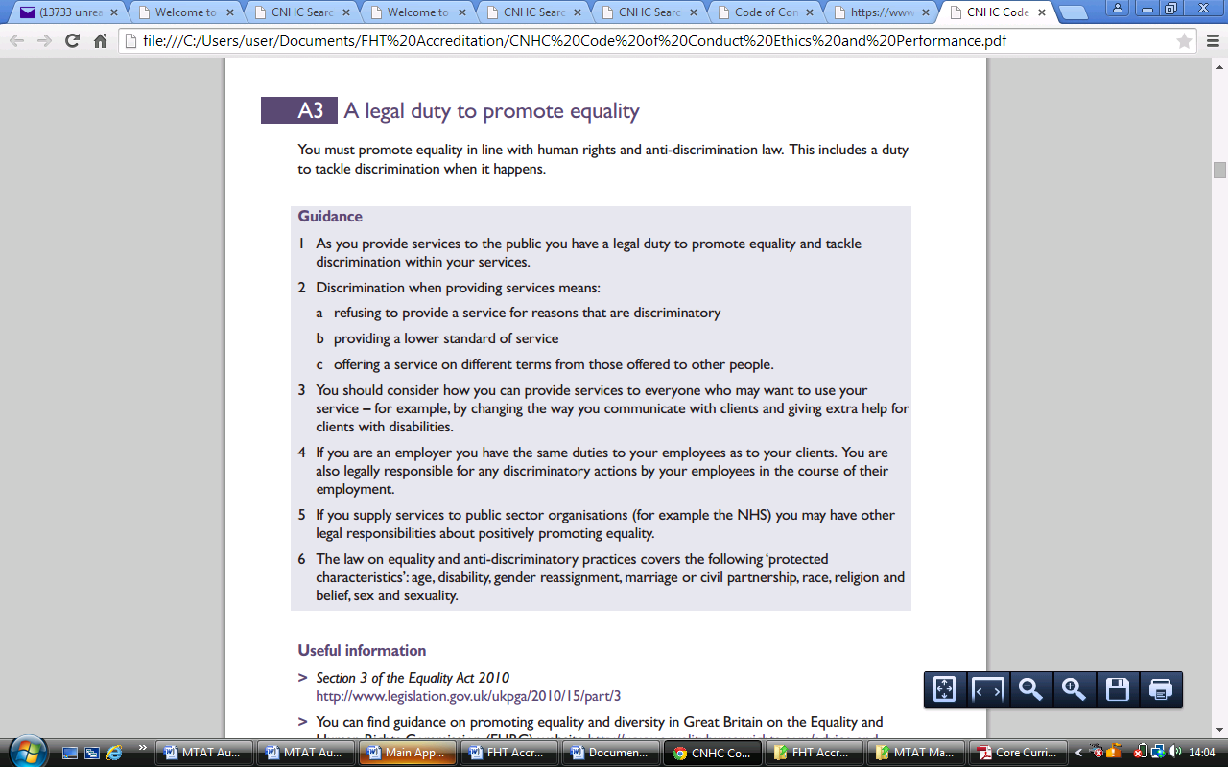

APPENDIX II

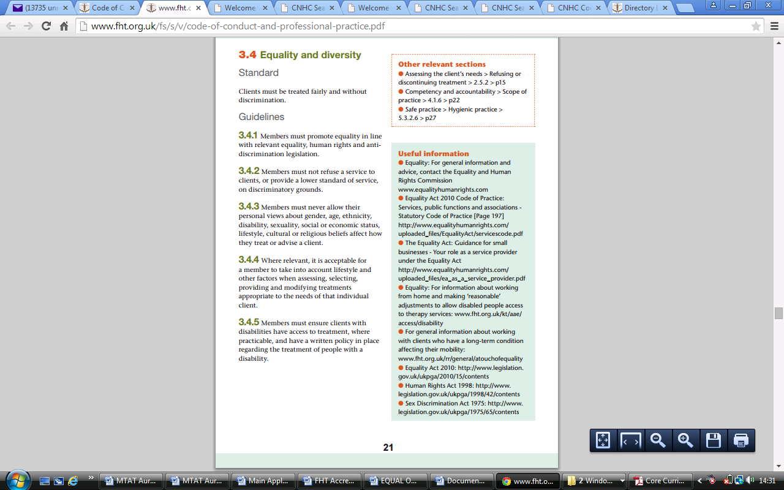

APPENDIX III

MTAT Monitoring form

MTAT expects to enable learners to have equal access to training and assessment for qualifications irrespective of their sex, marital status, age, religion, colour, race, nationality or ethnic origin or disability. Assessment must similarly be undertaken without discrimination. This form is strictly confidential but not anonymous, for the purposes of ensuring fairness and access to opportunity.

Name:....................................................................

## Monitoring ethnicity

MTAT asks that you to respond to this information request positively as it will help us ensure that our policies and practices do not inadvertently discriminate against you because of your ethnicity. MTAT assures you that any information you provide here will only be used to monitor the effectiveness of our policies.

### Monitoring questions:

#### How would you describe yourself?

Choose ONE section from A to E, and then tick the appropriate box

A  Asian or Asian British

Bangladeshi

Indian

Pakistani

Any other Asian background, please write in box .......................

B  Black or Black British

African

Caribbean

Any other Black background, please write in box .......................

C  Chinese or other ethnic group

Chinese

Any other, please write in box .......................

D  Mixed Heritage

White and Asian

White and Black African

White and Black Caribbean

Any other Mixed background, please write in box ......................

E  White

British

English

Irish

Scottish

Welsh

Any other White background, please write in box ......................

F  Prefer not to say

## Disability monitoring

To make positive changes, MTAT wants to address the different barriers faced by disabled people and create an environment where barriers are removed for disabled people. Many people who do not consider themselves to be disabled may be covered by the Equality Act 2010 because they have a health condition that has an impact on their lives. This information will remain confidential.

### Monitoring questions:

#### Do you consider yourself to have a disability or a long-term health condition?

Yes  No

#### What is the effect or impact of your disability or health condition?

Prefer not to say

## Gender monitoring

Gender monitoring is key to ensuring that all students have access to the same opportunities and MTAT is committed to work at achieving this.

### Monitoring question:

#### Would you describe yourself as:

Male  Female  Prefer not to say

## Sexual orientation

Monitoring sexual orientation in our students is a significant step towards acknowledging gay, lesbian and bi sexual students and make sure our processes and practices are fair to all students.

Please help us and do this by completing the following questions around your sexual orientation.

### Monitoring question:

#### What is your sexual orientation?

Bisexual

Gay man

Gay Woman / Lesbian

Heterosexual / Straight

Other

Prefer not to say

## Age monitoring

Age discrimination regulations at MTAT establishments are designed to ensure that you are judged only by your abilities and not your age. To help us confirm your age please state your date of birth.

### Monitoring question:

What is your Date of Birth?

--/--/---- (dd/mm/yy) and age .................

## Religion and belief

MTAT is committed to ensuring fairness and equal access to all students whatever their faith or beliefs. Below is a list of religions that are the most commonly found in Britain listed in alphabetical orde. We acknowledge that the list is not exhaustive and if your religion is not specifically listed then we ask you not to take offence as none was intended.

### Monitoring question:

#### Please tick the box that best describes you:

Buddhist

Christian

Hindu

Jewish

Muslim

Sikh

Other Religion or Belief (please state) ............................

No Religion

Prefer not to say

APPENDIX IV

